**Submitted by : Spogmai Jan**

**Roll No : 2430 – 0081**

**Submitted to : Sir Bilal Dar**

**Subject : PF LAB**

Lab Task 07:

Task 1:

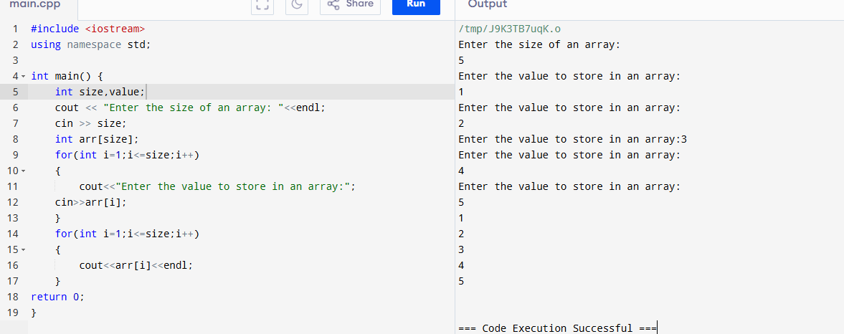

TASK 2:

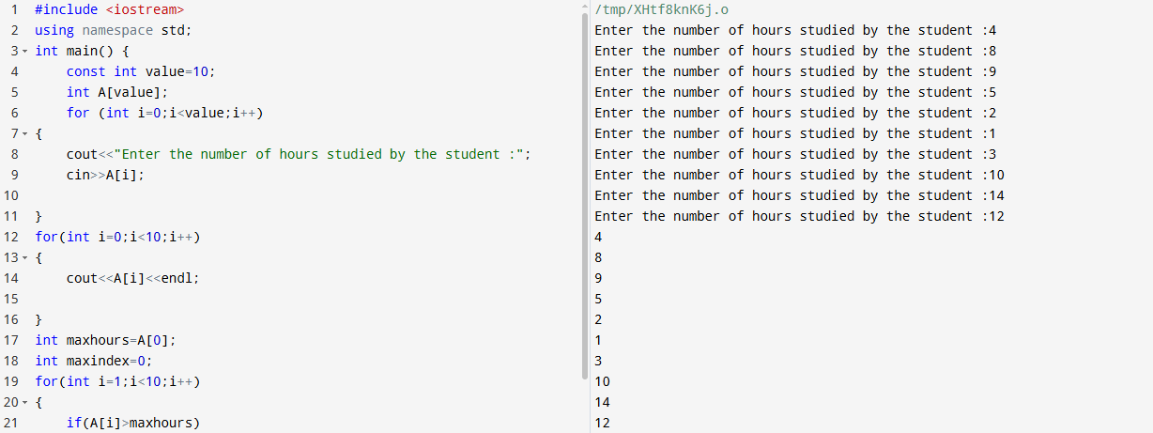

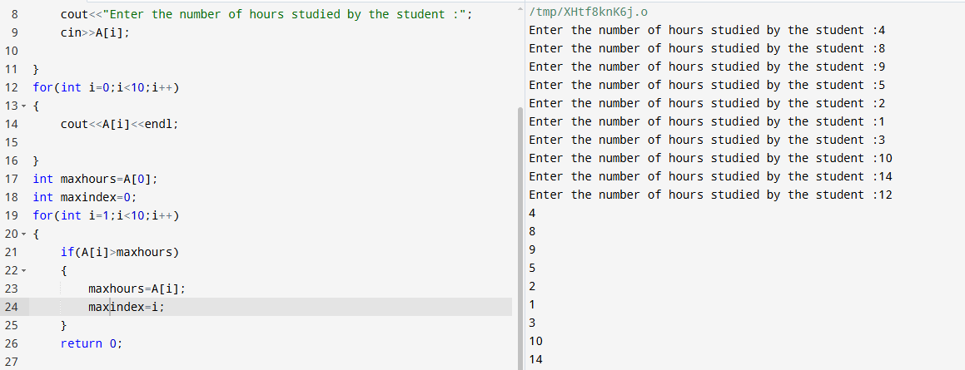

Task 03:

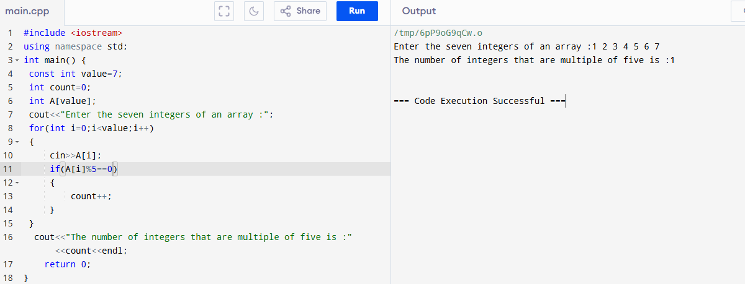

Task 04:

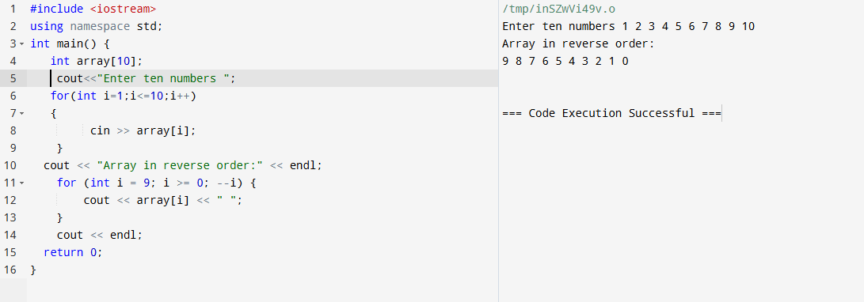

Task 05:

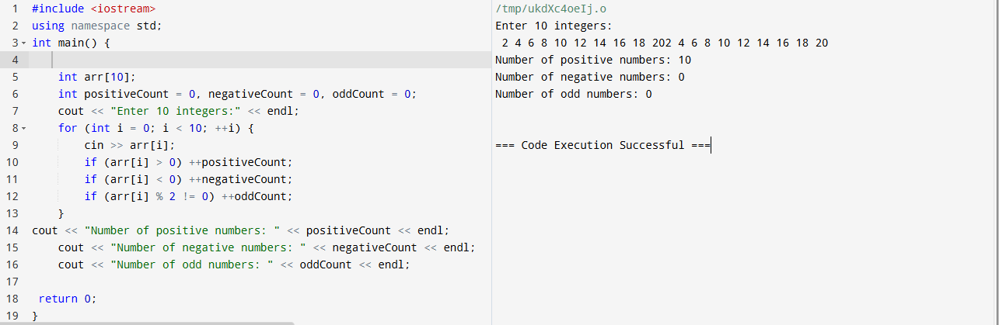

-----THE END-----